Prior learning
What do Jews believe about God? – Y2
Future Learning
How do Jews demonstrate their faith through their communities? – Y6
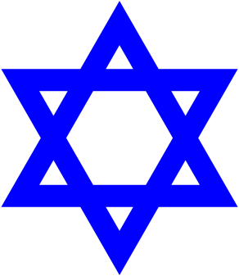
KNOWLEDGE ORGANISER
How do Jews show faith through practices and celebrations?

Key Vocabulary
5 Fingers | Judaism, Jews, Torah, Hebrew, Synagogue.
Shabbat | The Jewish day of rest. Families share a special meal to remember the Earth was created in 7 days.
Mezuzah | Metal or wooden prayer holder placed on each doorway (not toilet!). Contains the Shema. Jews touch it to remember God.
Shema | Jewish prayer which is held inside the mezuzah.
Purim | Jewish holiday to remember the Jews being saved from Haman. Celebrated with music, food, drink, costumes and dance.
Hanukkah | Festival of lights. Celebrates the Jews taking back the temple for God.
Esther | A beautiful Jewish lady who became Queen of Persia. She saved the Jews from being harmed by being brave and honest.
Bravery | Having the strength to face something or someone dangerous, scary or difficult.
Honesty | To speak and act truthfully.
Respect | A positive feeling shown towards someone or something important.
Holy | Something very special because it is connected to God.
Our Enquiry Steps:
How do Jews remember Shabbat?
What is the symbolism of the Shabbat meal?
What does “God is One” mean?
How did Esther show honesty and bravery? How is this remembered at Purim?
How do Jewish families and their communities celebrate Hanukkah?
Who are the Jewish Matriachs and Patriachs?

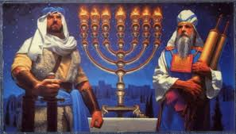
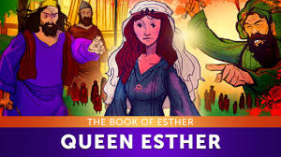
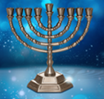
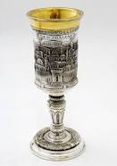
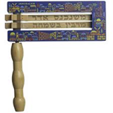
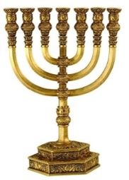
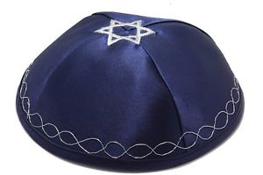
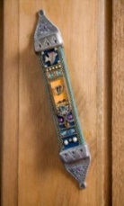
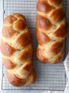
Key Stories
Key Artefacts and Symbols

