KNOWLEDGE ORGANISER
Why do Christians think about Incarnation at Christmas?

Prior learning
- Why is the Bible a special book for Christians? – Y2
- Who was Jesus and why is he important to Christians today? – Y2
Future Learning
- What is the Kingdom of God and what do Christians believe about the afterlife? – Y6
Key Vocabulary
Incarnation | Is the belief that Jesus, who is the non-created second person of the  triune God; took on a human body and everything that is human and became both man and God.
Prince of Peace | Jesus alone is able to restore every broken relationship, provide a well-ordered and balanced life, and offer assurance of eternal life.
Christingle | Is a symbolic object used in the Advent, Christmas, and Epiphany services of many Christian denominations. Christingle, from a word of German origin, Christkindl, meaning 'Little Christ Child', is used to celebrate Jesus Christ as the "Light of the World".
Word made Flesh | The premise of the Bible is that the God who created the universe wants to be known by human beings. ... God the only Son, who is at the Father's side, has made God known” (1:18). We speak of this idea of the Word becoming flesh as the Incarnation.
Gaudete’ | Is a Latin verb that means rejoice. Gaudete Sunday is the 3rd Sunday of Advent.
Pilgrim/Pilgrimage | A person who travels to a holy place as an act of religious devotion.  A pilgrimage is when people travel to a place of worship that is usually far away and is done for spiritual or religious reasons.
Worship | To honour or respect as a divine being

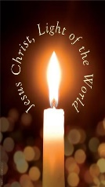
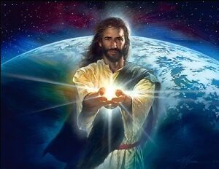
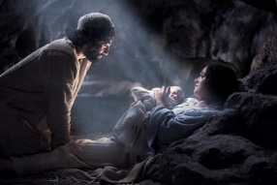
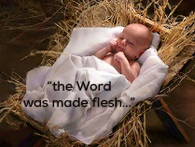
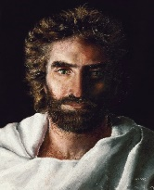
Jesus the Light of the World
Incarnation of Jesus
Word Made Flesh

Prince of Peace
Key Stories
Hope of Heaven https://www.youtube.com/watch?v=_O6PAV2cFCU

Key Songs
Our Enquiry Steps:
How do different Bibles tell the story of the Nativity?
What is a Christingle and how does it help us develop our understanding of the Incarnation?
Why is the incarnation an important concept in Christianity?
How do Christians around the world celebrate the Incarnation?
How can we think more deeply about incarnation using Christmas Carols?
How do Christians worship at Christmas? which words from the Bible about incarnation may be read in church at this time?

