Prior learning
- EYFS
Future Learning
- How do Hindus worship? – Y4
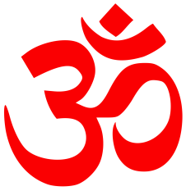
KNOWLEDGE ORGANISER
How do Hindus view God and how is Diwali celebrated?

Key Vocabulary
5 Fingers | Hinduism, Hindu, Vedas, Sanskrit, Temple / Mandir.
Brahman | The concept of God in Hinduism – infinte with no beginning and no end.
Aum | Most sacred Hindu symbol – like calling God’s name. Usually related to Shiva.
Trimurti | The three aspects of God in His forms as Brahma, Vishnu and Shiva. Also known as the Hindu Trinity.
Brahma | The Creator
Vishnu | The Preserver or Sustainer
Shiva | The Destroyer
Ganesha | Elephant-headed god. God of wisdom, success and good luck.
Ramayana | The story of Rama and Sita, celebrated during Diwali.
Diwali | Hindu festival of light.

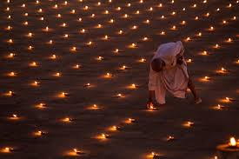
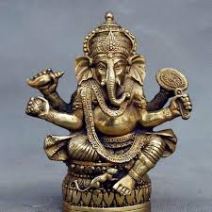
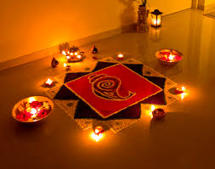
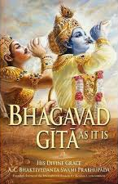
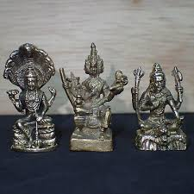
Our Enquiry Steps:
How do Hindus view God?
What is the Trimurti?
Why does this murti have the head of an elephant and the body of a boy?
How do Hindus celebrate Diwali?
How does the Ramayana teach Hindus about good and evil?
Which words of wisdom from the Bhagavad Gita are important to you? How would these words be viewed by a Hindu?
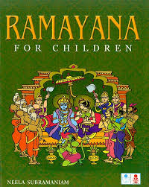
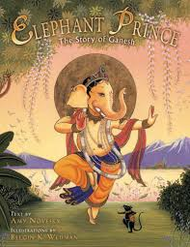
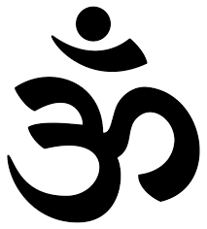
Key Stories
Key Artefacts and Symbols

