Prior learning
Future Learning
- What is Humanism? – Y6
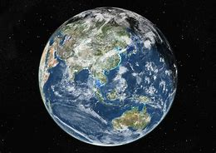
KNOWLEDGE ORGANISER
What is a Humanist?

Key Vocabulary
Humanist | Someone who believes in the values of Humanism.
Humanism | A worldview which is not religious. Believe the world is a natural place, should be free to do what makes us happy, should be kind to people, animals and the planet. One life to live.
Science | Learning about the world through observing, questioning and carrying out experiments
Evidence | Using facts to decide whether something is true or not true.
Empathy | Being able to understand and share the feelings of others.
Golden Rule | To treat others as you wish to be treated yourself. Seen in many worldviews.
Happy Human | The logo of Humanists UK which has also been adopted by some other Humanists around the world.
Celebrant | Someone who leads a special ceremony marking a life event including the welcoming of a baby, a wedding and a funeral.

Key Symbols
Our Enquiry Steps:
What different beliefs might people have?
How might people celebrate the birth of a baby?
What decisions might a Humanist make?
What do Humanist believe?

Key Ideas

