Prior learning
Future Learning
What are some of the differences and similarities within Christianity locally and globally? – Y6
Key Vocabulary
5 Fingers | Christianity, Christian, Bible, Hebrew, Aramaic, Greek, Church
Christian Symbols | Things that Christians have or wear to show that they belong to the church.
Jesus | Christians believe Jesus is God’s Son, part of the Trinity of Father, Son and Holy Spirit. The Messiah and The Saviour.
Baptism | Infant baptism when babies are welcomed into the family of God, the church, Jesus’ family
John the Baptist | Jesus’ cousin who was baptising people in the Jordan and who baptised Jesus.
Total immersion Baptism | People are fully submerged in the water and it symbolises a new start. This is the way that some people show they want to belong to Jesus
KNOWLEDGE ORGANISER
What does it mean to belong?

Our Enquiry Steps:
How am I special?
Why do Christians believe that people are special?
What does it mean to belong?
What different religions are there in the world?
Which of the symbols are associated with Christianity?
What symbols can I see in a baby’s baptism?
How was Jesus baptised?
Why do some adults choose to be baptised?
What is special about belonging?

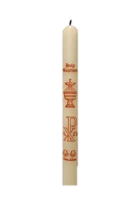
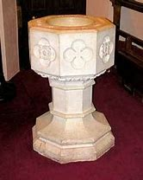
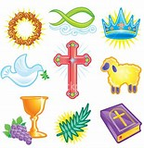
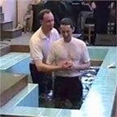
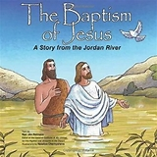
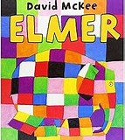
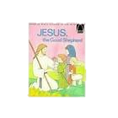
Key Artefacts and Symbols
Key Stories

