KNOWLEDGE ORGANISER
What do I think about Jesus and how is he portrayed in art around the world?

Key Vocabulary
Jesus | Believed by Christians to be the Son of God and Saviour
Appearance | Followers of Jesus
Portrayed | People who believe in One God who made the world (Creation Story) and that Jesus Christ is the Son of God.
Rosary beads | Of the 90 times Jesus was addressed directly in the gospels, 60 times he was called Teacher. Jesus teaches us through the parables.
El Salvador Cross | A short story that teaches a moral or spiritual lesson especially : one of the stories told by Jesus Christ and recorded in the Bible.
Orthadox Crucifix | Jesus performed extraordinary events of good which were taken as a sign of the power of God.
Christian/ Latin Cross | Make someone better
Prior learning
- Who was Jesus and why is he important to Christians today? – Y2
Future Learning
- What can we learn from Christian religious buildings and music? – Y6
- What is the Kingdom of God and what do Christians believe about the afterlife? – Y6

Our Enquiry Steps:
How do pictures of Jesus from around the world show a personal relationship with Christians?
Why do some Christians like to have a personal image of Jesus? What are rosary beads? How would I portray Jesus in art?
What do the Gospels tell us about Jesus as a person? Can we find links to pieces of art based on text?
Jesus described himself as “The bread of Life, The Light of the World and The Good Shepherd.” How has this inspired art?
What can we recognise as a symbol on crosses from El Salvador?

Key Artefacts and Symbols
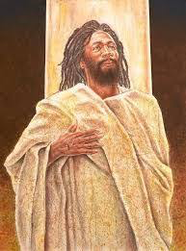
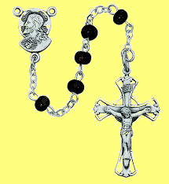
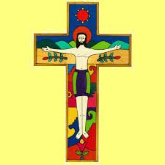
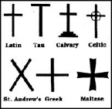
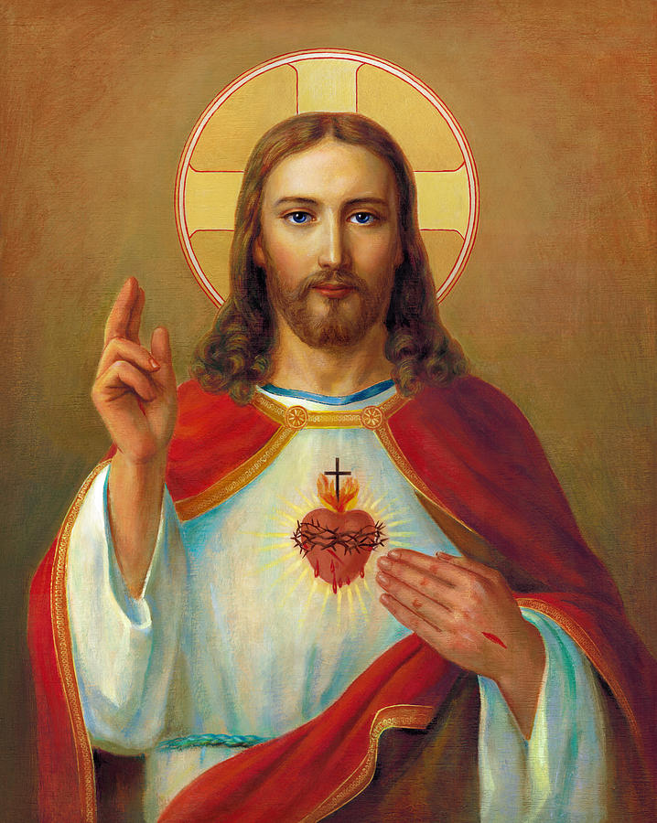
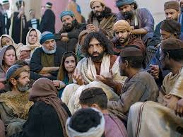
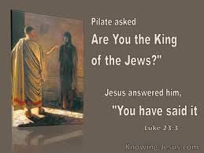
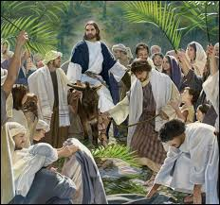
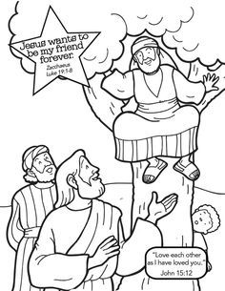
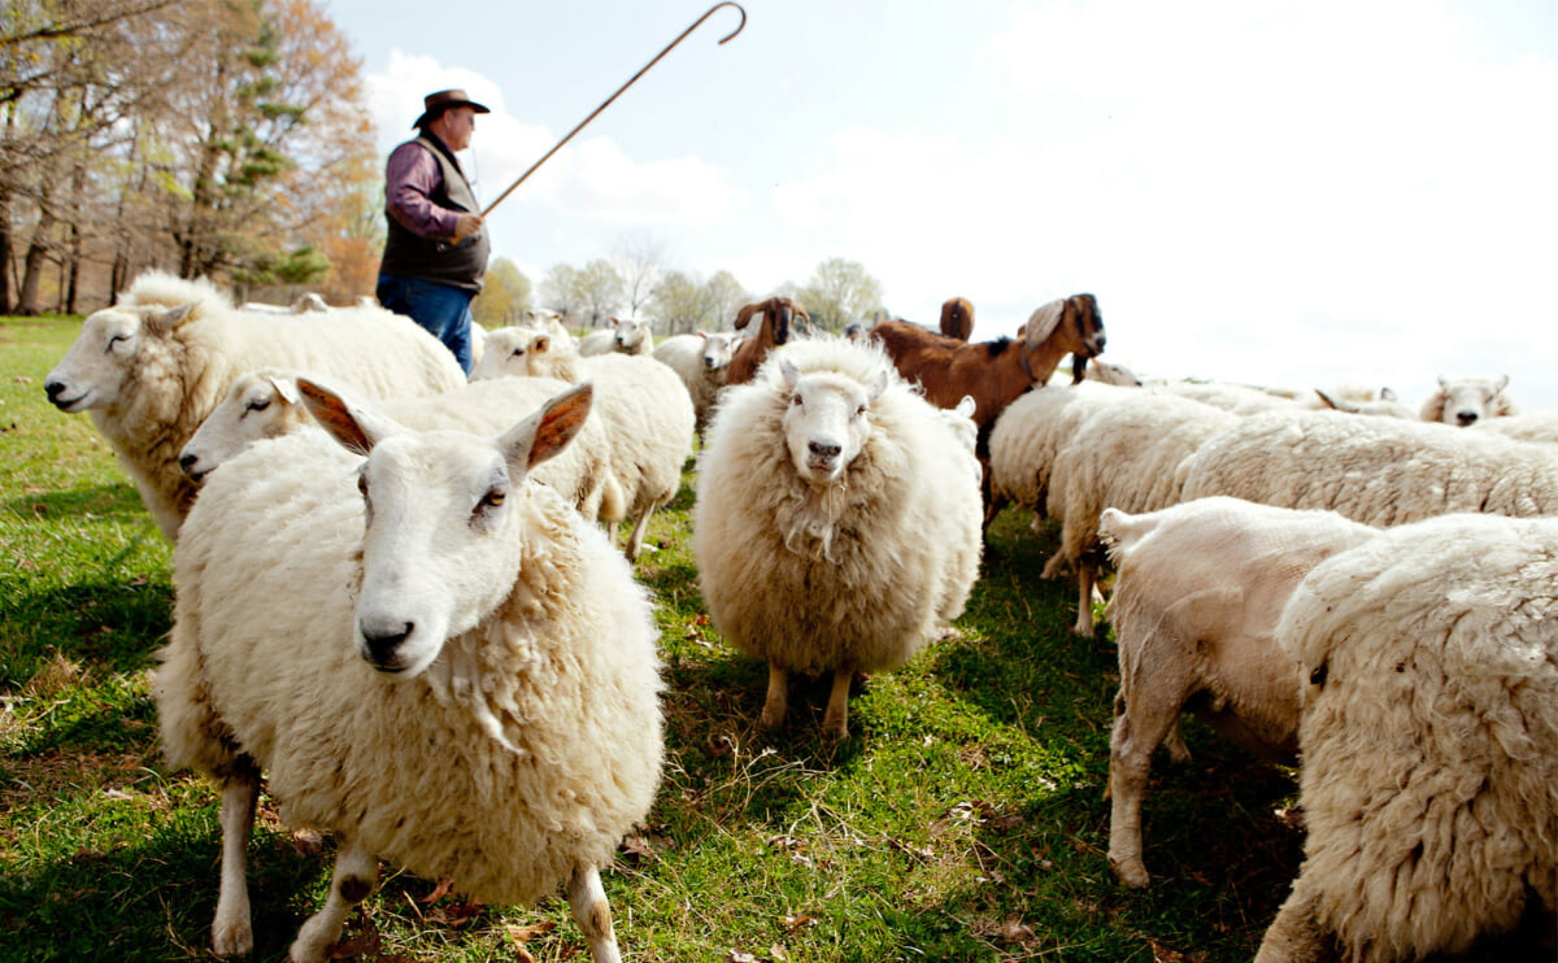
Key Stories

