Prior learning
Future Learning
- Why did Jesus teach people through stories?– Y2
- How do Christians use the Bible to help them with their lives? – Y3
- How did Jesus teach about God and values through parables? – Y4
KNOWLEDGE ORGANISER
Why is the Bible a special book for Christians?

Key Vocabulary
5 Fingers | Christianity, Christian, Bible, Hebrew, Aramaic, Greek, Church
Jesus | Christians believe Jesus is God’s Son, part of the Trinity of Father, Son and Holy Spirit. The Messiah and The Saviour.
Sacred Text | The term used for when a book is special for people who follow a religion. May include words which originate from God.
Bible | The sacred text for Christians is called the Bible. It is the best selling book of all time. Lots of different authors, books, chapters and verses. Teaches Christians about God. Some of it is important for other religions too.
Testaments | The Bible is split into two parts called Testaments. The Old Testament and The New Testament.
Gospels | The first four books in the New Testament are called the Gospels. They were written by four of the Disciples, Matthew, Mark, Luke and John. These books tell you about the life of Jesus.
Wisdom | The words in sacred texts which help a believer to make the right decision using knowledge and experience.
Prayer | Words which are said in the mind or out loud as a way of communicating with God for believers. Thanks, help, praise, forgiveness.
Belief | When someone feels that something is certain, exists or is true but to others it may not be proven.

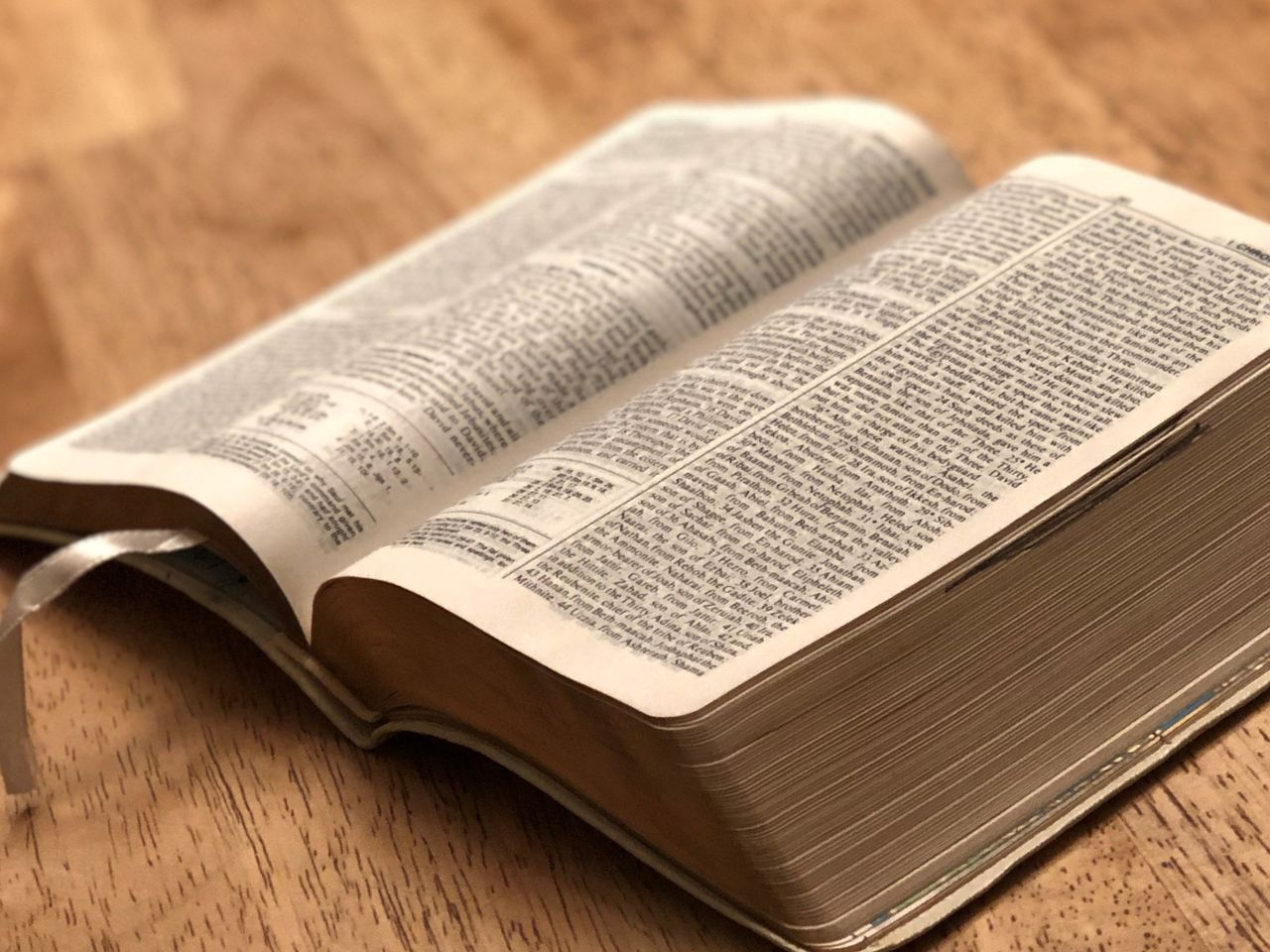
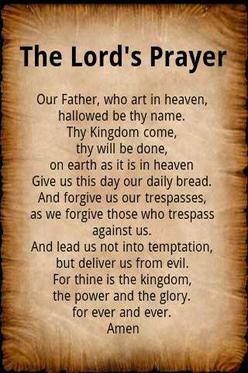
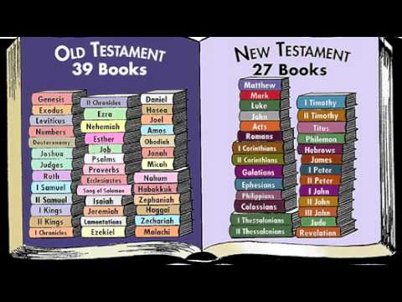
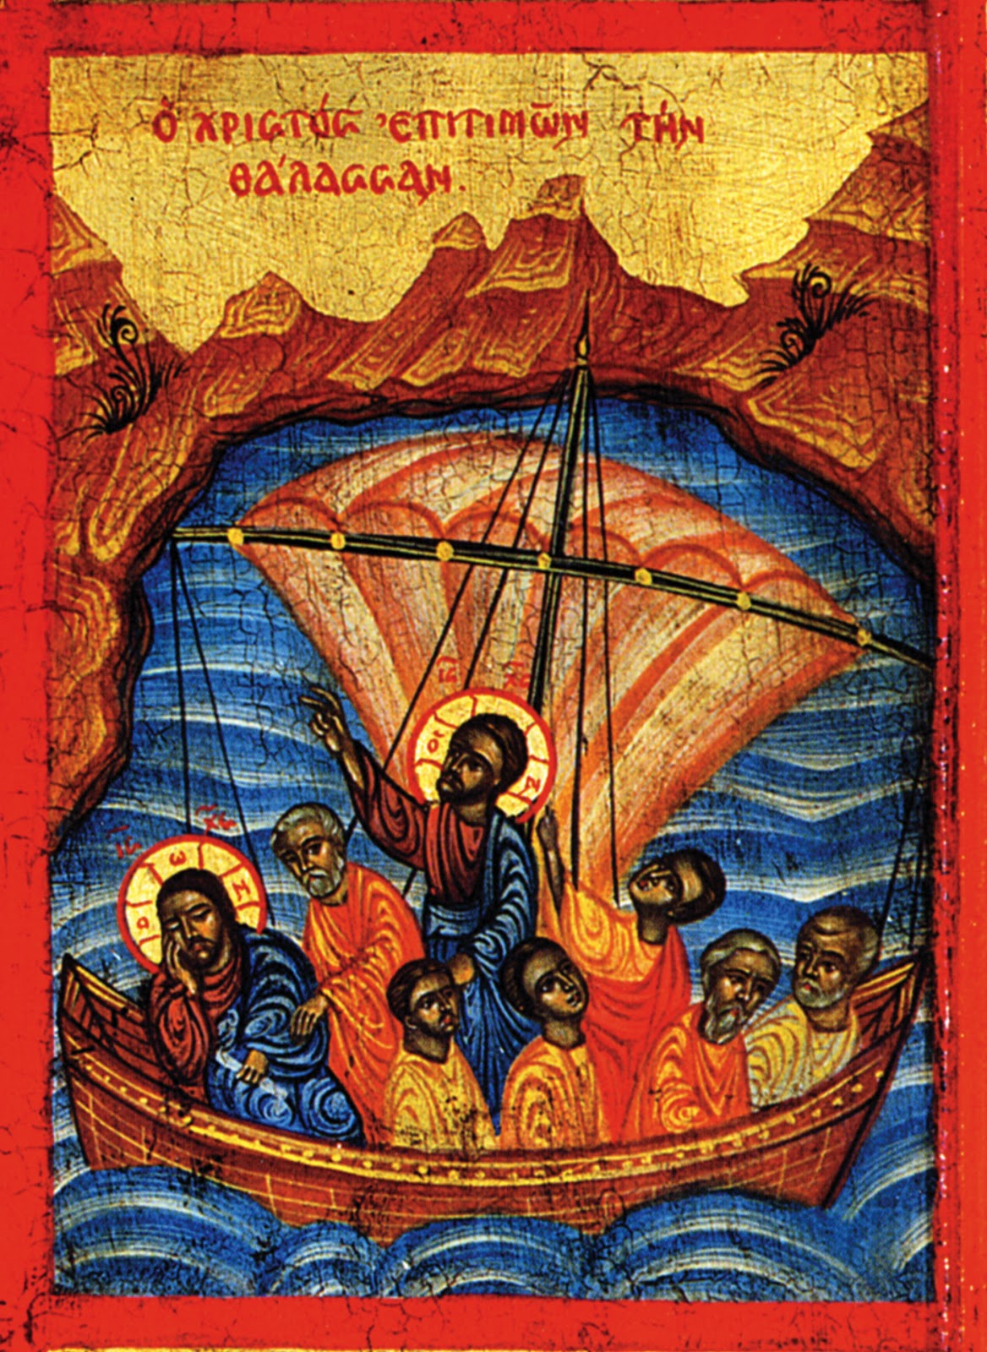
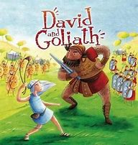
Our Enquiry Steps:
What makes a book special?
What sorts of different books are in the Bible?
What words of wisdom are in the Bible?
What could the story of David and Goliath teach a Christian?
How does the story of the stilling of the storm help Christians?
What prayers are there in the Bible and why do Christians pray?

Key Artefacts and Symbols
Key Stories

