|  |
| --- |
| **Prior learning** |
|  |
| **Future Learning** |
| * What do Jews believe about God? – Y2 |

|  |  |
| --- | --- |
| Key Vocabulary | |
| 5 Fingers | Christianity, Christian, Bible, Hebrew, Aramaic, Greek, Church |
| God | Christians believe that God created the universe and that he loves us and cares for us like a father. |
| Creation | When God made the universe and everything in it - including us! |
| Symbols | A sign, shape or action that represents a bigger idea |
| Stewardship | When we are using carefully and looking after all the things which God has given us in our world. |
| Good News | This is the message from Jesus that God loves them and he   * will forgive them when they go wrong. |
| Bible | The Christian sacred text which tells Christians all about God and how to live their life. |

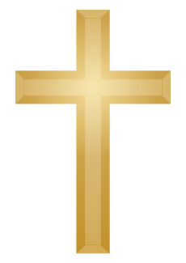

**KNOWLEDGE ORGANISER**

**What do we think about how the world was made and how we look after it?**

**Our Enquiry Steps:**

What beauty can you see in the world around you?

What does beauty mean?

What does the Bible say about how the world was created?

What other views are there about how the world began?

How did St Francis care for creation?

How can we be stewards of creation?



**Key Stories**

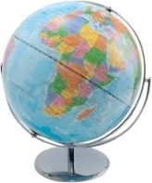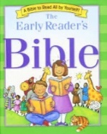

**Key Artefacts and Symbols**