Prior learning
Why is Christmas celebrated by Christians? – Y1
Future Learning
Why did Jesus teach people through stories? – Y2
What do I think about Jesus and how he is portrayed in art from around the world? – Y3
How did Jesus teach about God and values through parables? – Y4
What are some of the differences and similarities within Christianity locally and globally? – Y6
KNOWLEDGE ORGANISER
Who was Jesus and why is he important to Christians today?

Key Vocabulary
Jesus | Believed by Christians to be the Son of God and Saviour
Disciples | Followers of Jesus
Christians | People who believe in One God who made the world (Creation Story) and that Jesus Christ is the Son of God.
Jesus the Teacher | Of the 90 times Jesus was addressed directly in the gospels, 60 times he was called Teacher. Jesus teaches us through the parables.
Parable | A short story that teaches a moral or spiritual lesson especially : one of the stories told by Jesus Christ and recorded in the Bible.
Miracle Maker | Jesus performed extraordinary events of good which were taken as a sign of the power of God.
Healer | Make someone better
Crucifixion | Death on the cross
Resurrection | The Christian belief that he returned to life by a miracle. He died by crucifixion on Friday and rose from his tomb to new life on Sunday morning. This belief is celebrated at Easter. This gives Christians the hope of a new life after death.
The Bible | The Bible is the biggest selling book in the world! Bibles come in all different shapes and sizes and it is translated into 400 different languages too. The Bible was written long ago by many different authors and includes books of history, songs, poetry, letters, prayers plus much more!
New Testament | The Old Testament is the first part of the Bible and it’s made up of 39 books. Before Jesus, the story of the Jews.
Pilgrimage | A journey to a holy place

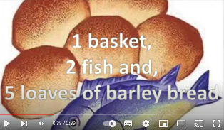
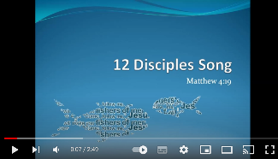
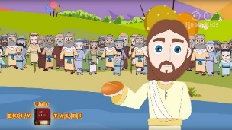
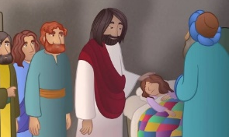
Our Enquiry Steps:
Who were the disciples?
Why was Jesus a teacher and leader? What happened at the feeding of the 5000?
Why do Christians believe that Jesus was a healer?
Why was Jesus’ death part of a bigger plan for Christians?
What is the resurrection?
Why do Christians follow Jesus?
One Basket - YouTube
https://www.youtube.com/watch?v=ULWDPd0CUgs
The Disciples Song - YouTube
https://www.youtube.com/watch?v=zfi3JRR1Nfc
Key Songs
The feeding of the 5000
Jesus calls the Fishermen
Jairus’ Daughter
Key Stories

