Prior learning
- What is a Humanist?
Future Learning
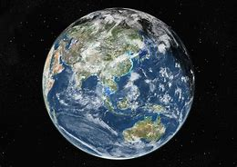
KNOWLEDGE ORGANISER
What is Humanism?

Key Vocabulary
Humanist | Someone who believes in the values of Humanism.
Humanism | A worldview which is not religious. Believe the world is a natural place not supernatuiral, should be free to do what makes us happy, should be kind to people, animals and the planet. One life to live. Science is the best way to understand the world.
Atheist | Someone who does not believe in God.
Agnostic | Someone who accepts people can’t know whether God exists or not.
Empathy | Being able to understand and share the feelings of others.
Golden Rule | To treat others as you wish to be treated yourself. Seen in many worldviews. An ethical principle.
Human Rights | A right which is believed to belong to every human regardless of race, sex, nationality, ethnicity, language, religion, or any other status.
Celebrant | Someone who leads a special ceremony marking a life event including the welcoming of a baby, a wedding and a funeral.
The Big Bang | The sscientific view of how the world began

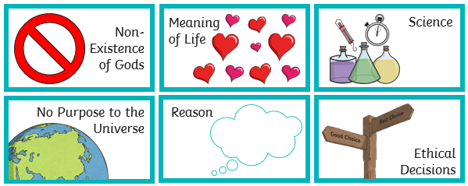
Our Enquiry Steps:
What us a worldview?
What are the key ideas of influential humanist thinkers?
Can I explore the ideas of Humanist thinkers?
Can I create a poster explaining Humanists beliefs to others?
Can I create a symbol representing a value?
Can I consider scenarios and decide how Humanists might respond?
Key Symbols
Key Ideas

