KNOWLEDGE ORGANISER
How and why do Christians worship? What are the benefits for believers?

Prior learning
- How do Muslims worship? – Y3
- How do Hindus worship? – Y4
- How do Sikhs worship? – Y5
Future Learning
- What are some of the differences and similarities within Christianity locally and globally? – Y6
- What is the Kingdom of God and what do Christians believe about the afterlife? – Y6
Key Vocabulary
5 Fingers | Christianity, Christian, Bible, Hebrew, Aramaic, Greek, Church
Worship | Love or devotion shown to a being or an object considered sacred.
Prayer | A form of worship that praises, requests or gives thanks to God or some other holy thing.
Community | A group of people living in the same place or having a particular characteristic or interest in common
Denomination | A religious group that has slightly different beliefs from other groups that share the same religion.
Ceremony | A formal religious or public occasion, done in a particular way, to celebrate a particular event, achievement or anniversary.
Humanism | A belief system based on the principle that people’s spiritual and emotional needs can be satisified without following a god or religion.

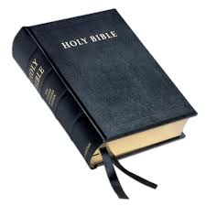
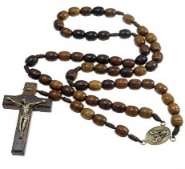
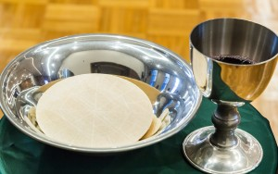
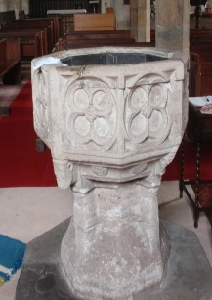
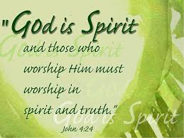
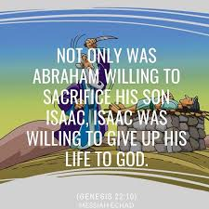
Key Symbols

Our Enquiry Steps:
What is worship?
Do you believe in ‘Something Greater’?
What is the purpose of prayer?
How do denominations worship in different and similar ways?
How do believers feel when they worship?
What is a spiritual encounter?
How is the joining of a denomination celebrated by the community?
What are the responsibilities of being part of community?
How do humanists celebrate?
Why are celebrations important to communities?

Key Stories

