Prior learning
- How do Hindus view God and how is Diwali celebrated? – Y3
Future Learning
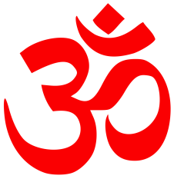
KNOWLEDGE ORGANISER
How do Hindus worship?

Key Vocabulary
5 Fingers | Hinduism, Hindu, Vedas, Sanskrit, Temple / Mandir.
Brahman | The concept of God in Hinduism – infinte with no beginning and no end.
Aum | Most sacred Hindu symbol – like calling God’s name. Usually related to Shiva.
Monotheism | Belief in one God.
Polytheism | Belief in several Gods.
Murti | Shrine figure.
Trimurti | The three aspects of God in His forms as Brahma, Vishnu and Shiva. Also known as the Hindu Trinity.
Shrine | A special place with links to God and worship.
Holi | A Spring festival celebrated in Feb/March in honour of Krishna.
Samskars | Rites of passage marking various life stages.
Reincarnation | The belief that after death you come back as another ‘being’.
Smasara | The name given to reincarnation.
Moksha | Escape or release from entrapment in the cycle of reincarnation (samsara).
Mother Earth | The earth considered as the source of all its living beings and natural features.

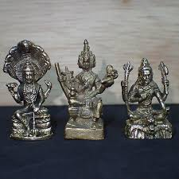
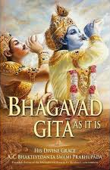
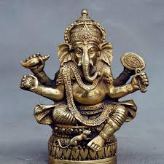
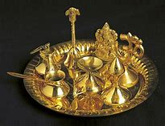
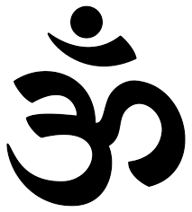
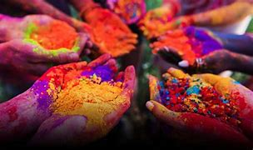
Key Artefacts and Symbols
Our Enquiry Steps:
What woudl a Hindu parent want their child to know about God?
What is the meaning of Aum?
What does it mean to have one God in many forms?
Is Hinduism monotheistic or polytheistic?
Why is a shrine important in a Hindu home?
What is Puja?
How do Hindus worship and celebrate at the festival of Holi?
What do Hindus understand about the journey of life?
What values about the family and how to care for the Earth are important for Hindus?

