WB 19.9.16 I am learning to read as a reader and writer. T A I
Can I answer questions about our class story by using a keyboard?
Can I use both hands to type?
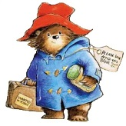
One day Pad went on a journey to London.

Where did Pad go on his journey?

First he went on the underground train. It was very noisy and Pad did not like it.

Why did Pad not like the underground train?

Next he saw the tower of London. It held the queens crown.

Where did Pad go after the underground train?

After that he saw the round London eye. He went up very high to see what he could see.

What word describes the London eye?

Later he walked over Tower Bridge and his hat flew off his head.

What happened when Pad went over the bridge?

Finally Pad went to Buckingham Palace to see the queen. He had a hot cup of tea and then he went home.

Who did Pad go to see at the palace?

What was Pad’s tea like?

